**PROJECT DESIGN PHASE – II**

**Data Flow Diagram and User Stories**

|  |  |
| --- | --- |
| DATE | 13/10/2022 |
| TEAM ID | PNT2022TMID08834 |
| PROJECT NAME | Plasma Donor Application |
| MAXIMUM MARKS | 4 marks |

**DATA FLOW DIAGRAMS:**

**LEVEL 0:**

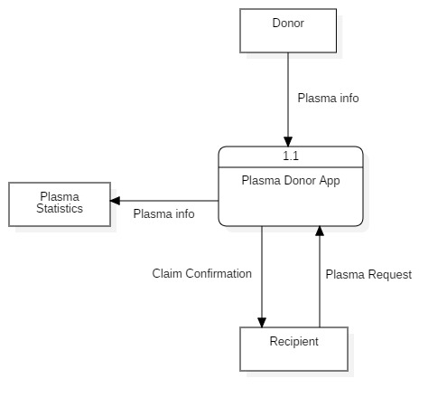

**LEVEL 1:**

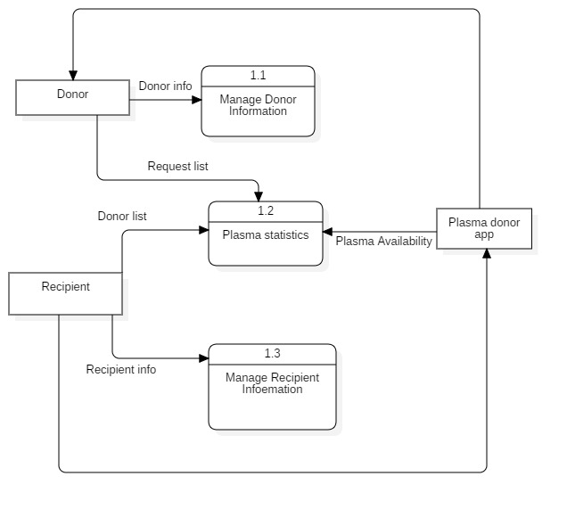

**USER STORIES:**

|  |  |  |  |  |  |  |
| --- | --- | --- | --- | --- | --- | --- |
| **User Type** | **Functional requirement** | **User Story Number** | **User story/task** | **Acceptance Criteria** | **Priority** | **Release** |
| Donor | Registration | USN-1 | As a user, I can register for the application by entering my email, password, and confirming my password. | I can access my account / dashboard | High | Sprint-1 |
|  | Login | USN-2 | As a user, I can log into the application by entering email & password | I can receive confirmation email & click confirm | High | Sprint-2 |
|  | Donation list | USN-3 | As a user, I can log into the application and see the request and also receive request. | I can see the requests and accept or reject it. | High | Sprint-3 |
| Recipient | App Registration | USN-4 | As a user, I can register for the application by entering my email, password, and confirming my password. | I can access my account / dashboard | High | Sprint-1 |
|  | Login | USN-5 | As a user, I can log into the application by entering email & password | I can receive confirmation email & click confirm | High | Sprint-2 |
|  | Plasma Request | USN-6 | As a user, I can enter into the application and find the donor and request for plasma. | I can register & access the dashboard with Login and request plasma. | Medium | Sprint-3 |
|  | Find donor | USN-7 | As a patient, I can directly access the application and find the plasma donor | I can access my account / dashboard | High | Sprint-3 |

|  |  |  |  |  |  |  |
| --- | --- | --- | --- | --- | --- | --- |
| **User Type** | **Functional Requirement** | **User Story Number** | **User story/Task** | **Acceptance criteria** | **Priority** | **Release** |
| Admin | Login | USN-8 | As Administrator, I can login into the app. | I can access the app details | High | Sprint-1 |
|  | Maintain database | USN-9 | As Administrator I can hold the exact details of donor and recipient and availability of plasma. | I can access database | Medium | Sprint-4 |
| Bot | Help the user | USN-10 | As AI bot, i can hold the good communication between bank and user also help the user | I can access the dashboard | Medium | Sprint-4 |